|  |  |
| --- | --- |
| Semester | T.E. Semester VI – Computer Engineering |
| Subject | Mobile computing |
| Subject Professor In-charge | Prof. Sneha Annappanavar |
| Assisting Teachers | Prof. Sneha Annappanavar |
| Laboratory | M310A |

|  |  |
| --- | --- |
| Student Name | Deep Salunkhe |
| Roll Number | 21102A0014 |
| TE Division | A |

**Title: Study of Various generation of the Internet**



**Explanation:**

1G, 2G, 3G, 4G and 5G are the five generations of mobile networks where G stands for Generation, and the number denotes the generation number. 5G is the latest generation, whereas 1G networks are now obsolete. The cellular technologies GSM, UMTS, LTE and NR enable 2G, 3G, 4G and 5G, respectively.

Term Stands for Launch Year

1G First Generation 1979 (Obsolete)

2G Second Generation 1991

3G Third Generation 2001

4G Fourth Generation 2009

5G Fifth Generation 2019

| **Generation** | **Technology standard** | **Radio access technology** |
| --- | --- | --- |
| 1G – First Generation | AMPS, NMT, TACS, J-TACS, C-Netz | FDMA |
| 2G – Second Generation | GSM, D-AMPS, IS-95 | Combination of TDMA & FDMA, and Narrowband CDMA |
| 3G – Third Generation | UMTS (WCDMA) and CDMA2000 | Wideband CDMA and Narrowband CDMA |
| 4G – Fourth Generation | LTE (Long Term Evolution) | OFDMA and SC-FDMA |
| 5G – Fifth Generation | NR (New Radio) | OFDMA |

1G – First Generation

1G stands for the first generation of mobile networks that were designed to provide basic voice calling services. 1G networks started in the early 1980s and were introduced in different parts of the world through various FDMA-based analogue technologies, including AMPS, NMT, TACS, J-TACS and C-Netz.

2G – Second Generation

2G stands for the second generation of mobile networks that initially offered voice calls, text messages and limited mobile internet. 2G networks started in the early 1990s and were introduced in different parts of the world through various digital technologies, including GSM, D-AMPS and IS-95.

3G – Third Generation

3G stands for the third generation of mobile networks that offer voice, text and data services. The technologies that enable 3G are UMTS and CDMA2000 which are based on the CDMA technology. UMTS is the 3G technology for GSM, and CDMA2000 is the 3G technology for IS-95.

4G – Fourth Generation

4G stands for the fourth generation of mobile networks that are data-only networks enabled by the LTE technology. 4G networks use packet-switching to offer IP-based voice calls and text messages in addition to high-speed mobile data. LTE is the 4G technology for both UMTS and CDMA2000.

5G – Fifth Generation

5G stands for the fifth generation of mobile networks that are data-only and offer average download speeds of around 150 to 200 Mbps. It is the latest generation of mobile networks enabled by the New Radio technology (NR). 5G networks can offer latencies as low as one millisecond.

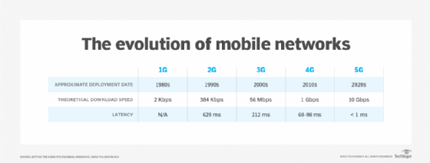

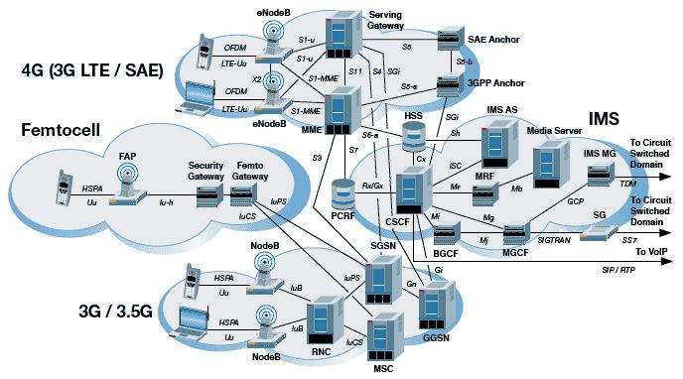

Sure, I can explain the architecture you sent me, which is a diagram of a typical 3G and 4G cellular network.

The network is made up of a number of different components, which can be broadly categorized into three main parts:

The User Equipment (UE): This is the mobile device that you use to connect to the network, such as your phone or tablet.

The Radio Access Network (RAN): This is the part of the network that is responsible for providing coverage and capacity for mobile devices. It consists of a number of base stations, which are connected to each other via a backhaul network.

The Core Network (CN): This is the part of the network that is responsible for routing calls and data between mobile devices and other networks. It consists of a number of different elements, such as the Mobile Switching Center (MSC), the Gateway GPRS Support Node (GGSN), and the Serving Gateway (S-GW).

The UE communicates with the RAN over the air interface, using a radio frequency (RF) signal. The RAN then forwards the signal to the CN, where it is routed to the appropriate destination.

The specific details of the architecture can vary depending on the type of cellular network (3G or 4G) and the specific vendor of the network equipment. However, the overall principles are the same.

Here are some of the key things to note about the architecture in the image:

The eNodeB is the base station for 4G networks. It is responsible for providing coverage and capacity for 4G devices.

The NodeB is the base station for 3G networks. It is responsible for providing coverage and capacity for 3G devices.

The MME is the Mobility Management Entity. It is responsible for managing the connections between UEs and the network.

The S-GW is the Serving Gateway. It is responsible for routing data traffic between UEs and the internet.

The HSS is the Home Subscriber Server. It stores information about subscribers, such as their phone numbers and billing information.

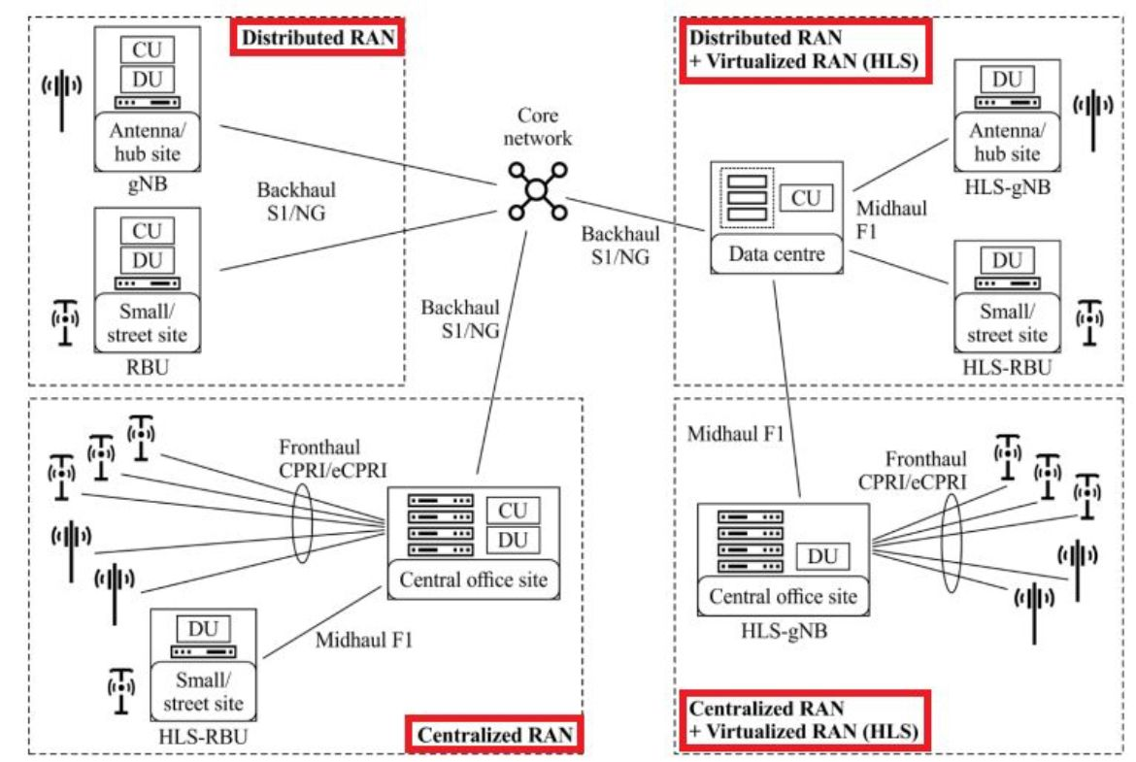

The architecture you sent me is a diagram of a distributed and virtualized Radio Access Network (RAN), which is a new approach to designing mobile networks. Traditional RANs are centralized, with all of the processing power and functionality located in a single cell site. This can make them expensive and inflexible to deploy, as well as difficult to scale.

Distributed RANs, on the other hand, are designed to be more flexible and scalable. They distribute the processing power and functionality of the RAN across multiple locations, such as cell sites, central offices, and even data centers. This can make them more cost-effective to deploy, as well as easier to scale to meet the demands of a growing network.

Virtualized RANs take this concept a step further by running the RAN functions on virtual machines (VMs) rather than dedicated hardware. This makes them even more flexible and scalable, as well as easier to manage and maintain.

The specific details of the architecture in the image can vary depending on the vendor and the specific use case. However, the overall principles are the same.

Here are some of the key things to note about the architecture in the image:

The Centralized Unit (CU) is the brains of the RAN. It is responsible for all of the control and signaling functions.

The Distributed Unit (DU) is responsible for the radio processing functions. It is typically located closer to the cell site than the CU.

The HLS-gNB and HLS-RBU are virtualized versions of the gNB and RBU, respectively. They can be run on any standard server hardware.

The fronthaul is the connection between the DU and the CU. It is typically a high-bandwidth, low-latency link.

The midhaul is the connection between the CU and the core network. It can be a variety of different types of links, depending on the specific deployment.  
  
Reference:  
<https://www.viavisolutions.com/en-uk/what-5g-architecture>

<https://www.interviewbit.com/blog/lte-architecture/>

<https://commsbrief.com/what-do-the-terms-1g-2g-3g-4g-and-5g-really-mean/#:~:text=The%20first%2Dgeneration%20mobile%20networks,the%20fifth%20generation%20(5G)>.

<https://www.techtarget.com/searchnetworking/feature/A-deep-dive-into-the-differences-between-4G-and-5G-networks#:~:text=The%20biggest%20difference%20between%204G,such%20as%20faster%20download%20speeds>.



**Conclusion:**

In conclusion, the evolution of mobile networks from 1G to 5G represents a remarkable journey in the realm of telecommunications. Each generation brought about significant advancements, from the basic voice calling services of 1G to the data-centric, high-speed capabilities of 5G. The transition from analogue to digital technologies, such as GSM, UMTS, LTE, and NR, has played a pivotal role in shaping the mobile communication landscape.

The progression through generations not only addressed the growing demand for enhanced services but also focused on improving security, efficiency, and coverage. The introduction of technologies like TDMA, CDMA, and OFDMA, along with the development of packet-switching and IP-based services, marked crucial milestones in the evolution of mobile networks.

The advent of 5G, with its New Radio (NR) technology and flexibility to operate in various frequency bands, brings forth a new era with unparalleled data rates, low latency, and the ability to cater to diverse use cases. From enhanced mobile broadband to massive Machine Type Communication and ultra-reliable low latency communications, 5G opens doors to innovative applications across industries.

While 4G LTE networks have matured and offer reliable mobile broadband services, 5G presents a substantial leap in performance, with average download speeds of 150 to 200 Mbps and the potential for much higher peak speeds. However, it's essential to acknowledge that 5G is still in its early stages, with most deployments being non-standalone, leveraging a combination of 4G and 5G networks.

As technology continues to advance, it's exciting to anticipate the further enhancements and widespread adoption of 5G, ushering in an era of connectivity that not only transforms our mobile experiences but also enables a plethora of innovative applications and services for both individuals and the Internet of Things (IoT).